**YEAR 12 CHEMISTRY - ATCHE**

**TEST 1**

**Reaction Rates and Equilibrium 2018**

**/ 47**

**-**

**Recommended time: 55 Minutes**

Name: ___________________________________________

Teacher: ___________________________________________

This test is in two parts.

**Part 1:** Multiple choice style test consisting of (12) questions. **(12 Marks )**

Each question is worth 1 mark.

Write your answers in the table provided.

Attempt ALL Questions

**Part 2:** Short and/or Extended Answer questions **(35 Marks)**

Write all answers in the spaces provided.

The marks allocated to each question are shown for each question

Note that questions DO NOT carry an equal number of marks.

Read the questions carefully and keep an eye on the allocated time

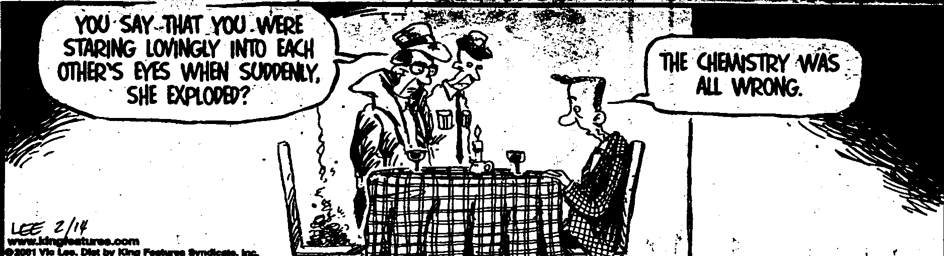

**PART 1: 12 Multiple Choice Questions. Write your answer neatly in the table below. This part is worth 12 marks.**

|  |  |  |  |  |  |  |  |  |  |  |  |
| --- | --- | --- | --- | --- | --- | --- | --- | --- | --- | --- | --- |
| **1** | **2** | **3** | **4** | **5** | **6** | **7** | **8** | **9** | **10** | **11** | **12** |
|  |  |  |  |  |  |  |  |  |  |  |  |

**The following information refers to questions 1, 2 and 3.**

Methanol a useful fuel and solvent can be manufactured from hydrogen and carbon monoxide:

**2H2 (g) + CO (g)** ⮀ **CH3OH(g)**

Examine the following potential energy diagram for the above chemical reaction:

Potential energy (kJmol−1)

300.0

200.0

100.0

0.0

Progress of reaction

1 Which one of the following descriptions is **true**?

A. It is an exothermic reaction with the heat of reaction ΔH = - 70 kJ

B. It is an endothermic reaction with the heat of reaction ΔH = + 200 kJ

C. It is an exothermic reaction with the heat of reaction ΔH = - 200 kJ

D. It is an endothermic reaction with the heat of reaction ΔH = + 70 kJ

2 The activation energy for the reaction **CH3OH(g) 2H2(g) + CO(g)** is:

A. + 70 kJ

B. + 220 kJ

C. - 220 kJ

D. + 150 kJ

3 The introduction of a catalyst to the equilibrium system:

**2H2 (g) + CO (g)** ⮀ **CH3OH (g)** would change

A. ΔH only

B. ΔH and the activation energy only

C. the activation energy only

D. the rate of the reverse reaction only

4 Raising the temperature of a reacting system increases the rate of the reaction, but does **not** increase the:

A. activation energy

B. average velocity of the reacting molecules

C. number of successful collisions

D. fraction of the reacting molecules which possess energies greater than the activation energy

5. The following equilibrium is established in a closed system.

**CO2(*g*) + H2O(*l*) ⮀ H2CO3 (*aq*) Δ*H* = –19.4 kJ mol–1**

How can the gas pressure in the system be decreased?

1. Add more CO2(*g*)
2. Add hydroxide ions to the solution
3. Decrease the volume of the container

D. Increase the temperature of the system

6. When silver sulfide is added to water, the following equilibrium is established:

**Ag2S (s) ⮀ 2Ag + (aq) + S 2 – (aq)**

The value of the equilibrium constant in this reaction is very small. What does this suggest?

1. Adding more silver sulfide will increase the amount of ions in solution.
2. Silver sulfide reacts extensively with water.
3. Silver sulfide has a very low solubility.
4. The reaction is endothermic.

7. Consider the following endothermic reaction taking place in a closed vessel

**N2O4 (g)** **⮀ 2 NO2(g)**

Which of the following actions would cause N2O4 to be produced in an increased

amount?

1. Adding a catalyst
2. Decrease the volume
3. Decrease the pressure
4. Increase the temperature

8. The equation describes an equilibrium reaction in a closed system which is

exothermic.

**X(g) + Y(g) ⮀ 4Z(g)**

Under which set of conditions would the highest yield of Z(g) be obtained?

|  |  |
| --- | --- |
| Temperature (°C) | Pressure (kPa) |
| 1. 50 | A,100 |
| 1. 50 | B. 200 |
| 1. 300 | C.100 |
| 1. 300 | D. 200 |

The next two questions, 9 and 10, are about the following reaction:

**4NH3 (g) + 3O2 (g) ⮀ 2N2 (g) + 6H2O (g) ΔH = - 1267 kJ**

Three changes can be made to the reaction:

I. Adding a catalyst.

II. Heating the mixture.

III. Increasing the pressure.

9. Which of the changes will increase the yield of the forward reaction?

1. I only.
2. II only.
3. III only.
4. None of the above.

10. Which of the changes will increase the rate of the forward reaction?

1. I only.
2. I and II only.
3. I and III only.
4. I, II and III.

11. What is the equilibrium constant expression for the dissolving of lead (II) chloride according to the following equation?

**PbCl2 (s) ⮀ Pb 2+ (aq) + 2 Cl –  (aq)**

A. K = [Pb 2+] [Cl – ]2

B. K = [Pb 2+] [2 Cl – ]

C. K = 

D. K = 

12. The following equilibrium mixture is established in a closed container:

**N2O4(g) ⇌ 2NO2(g); ∆*H* = +60 kJ**

N2O4 is a colourless gas but NO2 is a brown gas. If the temperature is decreased and the volume is kept constant, the colour of the equilibrium mixture will:

1. remain the same because both the forward and reverse rates are equally decreased
2. darken because the forward direction is favoured in getting back to equilibrium
3. lighten because the pressure will decrease
4. lighten because the reverse reaction is exothermic

END OF MULTIPLE CHOICE QUESTIONS – Part 1

**PART 2: Section B - Short answers and extended answers (****35 marks total)**

Answer **ALL** the questions in the space provided below. Note that **not** all questions carry equal number of marks.

**Question 13** **(8 marks)**

Chemistry of ocean acidification by increased levels of carbon dioxide is affected

principally by four equilibria.These involve the dissolving of CO2 gas in water, the

reaction of dissolved CO2 with water to form carbonic acid, the dissociation of

carbonic acid into hydrogencarbonate ions, and the dissociation of

hydrogencarbonate ions into hydrogen ions and carbonate ions.

In addition, calcium and carbonate ions present in the water also exist in an equilibrium to form calcium carbonate.

a) Using suitable equations when necessary, explain why an increase in atmospheric

CO2 could lead to fewer hard-shelled organisms in the ocean. (4 marks)

b) List three factors that could theoretically be altered to lessen the impact of CO2 on calcium carbonate shelled organisms. (1.5 marks)

c) Name and describe the agreement whereby most of the worlds companies attempted to minimise CO2 production. In your answer, include the year, the number of countries, and two achievements of the agreement. (2.5 marks)

**Question 14. (3marks)**

A student is given the task of reducing the concentration of free metal ions in

various aqueous samples. She is also supplied with ammonia solution. Ammonia is

capable of reacting with metal ions and forming complex ions, this decreases their

concentration in the solution. She adds the same volume of ammonia solution

(an excess) to each test tube initially containing 0.1 mol L–1 solutions of the metal

ions. The information about each reaction is shown below:

|  |  |  |  |
| --- | --- | --- | --- |
| **Test tube** | **Metal ion** | **Equilibrium reaction** | **Equilibrium constant (K)** |
| 1  2  3 | Cd2+  Cu2+  Zn2+ | Cd2+(aq) + 4NH3(aq) ⇌ Cd(NH3)42+(aq)  Cu2+(aq) + 4NH3(aq) ⇌ Cu(NH3)42+(aq)  Zn2+(aq) + 4NH3(aq) ⇌ Zn(NH3)42+(aq) | 1 × 107  1 × 1013  1 × 109 |

In which of the three test tubes, containing the equilibrium mixtures, will the

concentration of the ‘free’ metal ion be the smallest? Explain your reasoning.

___________________________________________________________________

___________________________________________________________________

___________________________________________________________________

**Question 15 (3 marks)**

Write the equilibrium constant (K) expression for the following reactions

a) Fe(NO3)3(s) + 6H2O(l) ⇌ [Fe(H2O)6]3+(aq) + 3NO3– (aq) ΔH = + 45 kJ mol-1

b)The reaction in (a) above is carried out at 25 °C. What will happen to the equilibrium constant (K) value if the temperature is increased to 75°C.

c) 2Hg(g) + O2(g) ⇌ 2HgO(s)

**Question 16 (5 marks)**

Ethene (C2H4) may be produced from ethane (C2H6) according to the following reversible reaction:

**C2H6 (g) ⮀ C2H4 (g) + H2 (g) ΔH = + 120 kJ mol – 1**

(a) State three conditions that increase the rate of the forward reaction.

1. ______________________________________________________ (1 Mk)
2. _______________________________________________________ (1 Mk)
3. ________________________________________________________(1Mk)

(b) State two conditions which would increase equilibrium yield (favour products).

1. _______________________________________________________(1 Mk)
2. _______________________________________________________(1Mk)

**Question 17 (4 Marks)**

The diagram below shows Maxwell – Boltzmann distribution for a sample of a gas at fixed temperature. Ea is the activation energy for the decomposition of this gas.

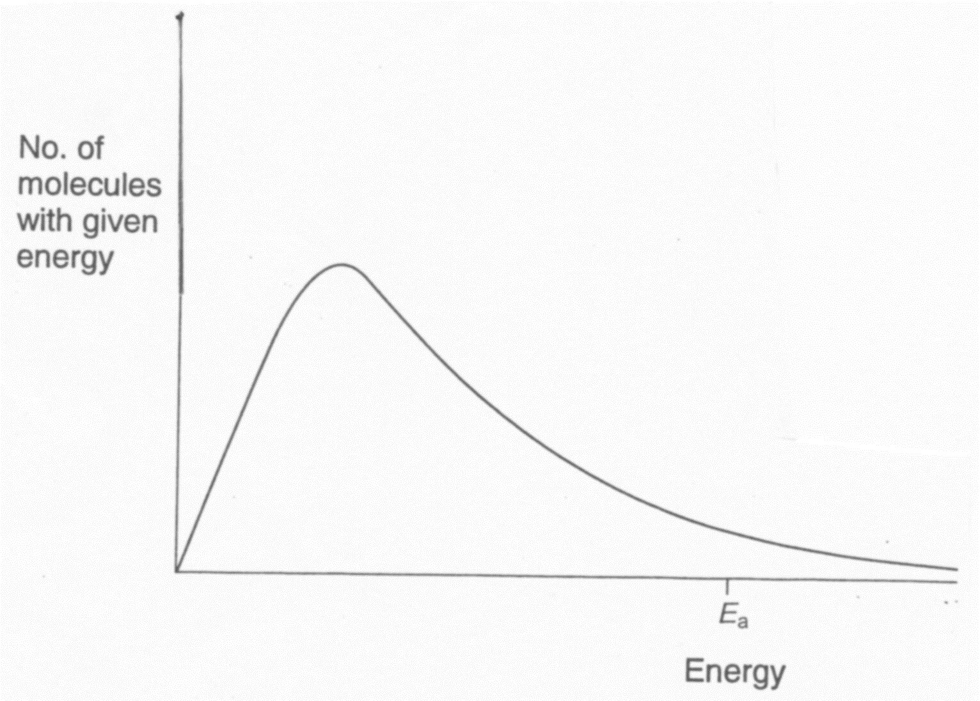

T1

Low Temp

20(a) On this diagram, sketch neatly the distribution for the same sample of gas at

high temperatures (T2) showing why an increase in temperature increases the rate of

a chemical reaction.

(2 marks)

20 (b) With reference to the Maxwell – Boltzmann distribution, **explain** why an

increase in temperature from T1 to T2 increases the rate of a chemical reaction. (2 marks)

___________________________________________________________________

___________________________________________________________________

**___________________________________________________________________**

**___________________________________________________________________**

**Question 18 (3 Marks)**

The following equilibrium is being investigated:

**2 ZnS (s) + 3 O2 (g) ⮀ 2 ZnO (s) + 2 SO2 (g) ΔH = - 879 kJ**

Three identical sealed boxes are set up, each containing the equilibrium mixture. Each

of the boxes is treated as described below, and time is allowed for a new equilibrium

to be established. In each case describe the change between the original equilibrium

and the new equilibrium.

|  |  |  |
| --- | --- | --- |
| Treatment | What happens to the rate of forward reaction?  Write ‘increases’, ‘decreases’ or ‘no change’ | What happens to the equilibrium position.  Write ‘move to the right’, ‘move to the left’ or ‘no change’ |
| A small amount of O2 (g) is added. |  |  |
| Ne (g) is pumped in, increasing the pressure of the system (no volume change). |  |  |
| The reaction vessel is heated. |  |  |

**Question 19**  **(9 Marks)**

Consider the equilibrium shown below by the following equation

**C(s) + H2O(g) ⇄ CO(g) + H2(g)**

The graph below represents the concentration of three species for the first 10

minutes of reaction, and afterwards when a change is made to the system at the

10 minute mark. The reaction is exothermic.

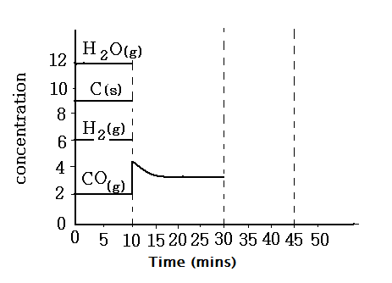

19. At the 10 minute mark, more CO gas is pumped into the system.

(a) Show on the graph a neat representation of the expected changes to the

concentration of the other two substances during the time 10 to 30 minutes. (3 marks)

19 (b) Use the collision theory to **explain** the changes of H2O, CO and

H2 between 10 and 30 minutes. (3 marks)

_________________________________________________________________

_________________________________________________________________

_________________________________________________________________

_________________________________________________________________

_________________________________________________________________

_________________________________________________________________

_________________________________________________________________

19 (c) At 30 minutes the reaction vessel is warmed up by increasing the temperature.

Neatly draw the concentrations of each species for the next 15 minutes. The

equilibrium is achieved at 45 minutes (3marks)

**END OF EQUILIBRIUM TEST 1 2018. GO BACK AND RE- CHECK YOUR ANSWERS**